

**Kauno technologijos universitetas**

fACULTY OF INFORMATICS

**T120B166 Development of Computer Games and Interactive Applications**

*Party Table Game - Saboteur*

IFF-6/11 Nerijus Dulkė

Date: 2019.03.05

KAUNAS

2019

**Contents**

Table of images 3

Table of Tables/functions 4

Game description 5

Laboratory work #1 6

List of tasks 6

Solution 6

Task #1. Create a map in at least 10x10 scenario elements 6

Task #2. Add at least 50 environmental elements 6

Task #3. Add lighting sources 7

Task #4. Complement the map with sound 9

Task #5. Use at least 20 different materials 10

Literature list 11

# Table of images

Figure 1 Table surface 6

Figure 2 Enviornmental elements 7

Figure 3 Light source example #1 7

Figure 4 Light source example #2 7

Figure 5 Light source example #3 8

Figure 6 Light source example #4 8

Figure 7 Light source example #5 8

Figure 8 Material preview 10

# Table of Tables/functions

Table 1 SoundList fragment 9

# Game description

1. **3D or 2D?** 3D
2. **What type is your game?** Board sgame
3. **What genre is your game?** Party game
4. **Platforms:** PC
5. **Scenario description:** In this game action is set in a mine. Players take on the role of dwarves, some are miners, some are saboteurs, but no one knows who is on their side. For miners goal is to get to the gold until the cards run out. For saboteurs the goal is to stop miners from reaching gold. After three rounds the player with the most gold wins.

# Laboratory work #1

## List of tasks

1. Create a map in at least 10x10 scenario elements.
2. Add at least 50 environmental elements.
3. Add lighting sources (at least 10 units, with different settings).
4. Complement the map with sound (at least 10 different sounds and at least 5 pieces of background music in different locations)
5. Use at least 20 different materials

## Solution

### Task #1. Create a map in at least 10x10 scenario elements

Since this is a table game, the “map” is a 15x15 table surface:

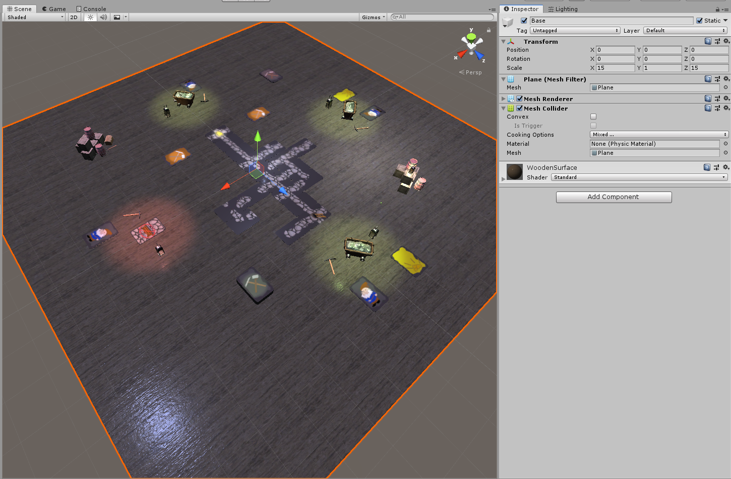

Figure 1 Table surface

### Task #2. Add at least 50 environmental elements

Environment consists of different types of cards, player items and some decorative assets:

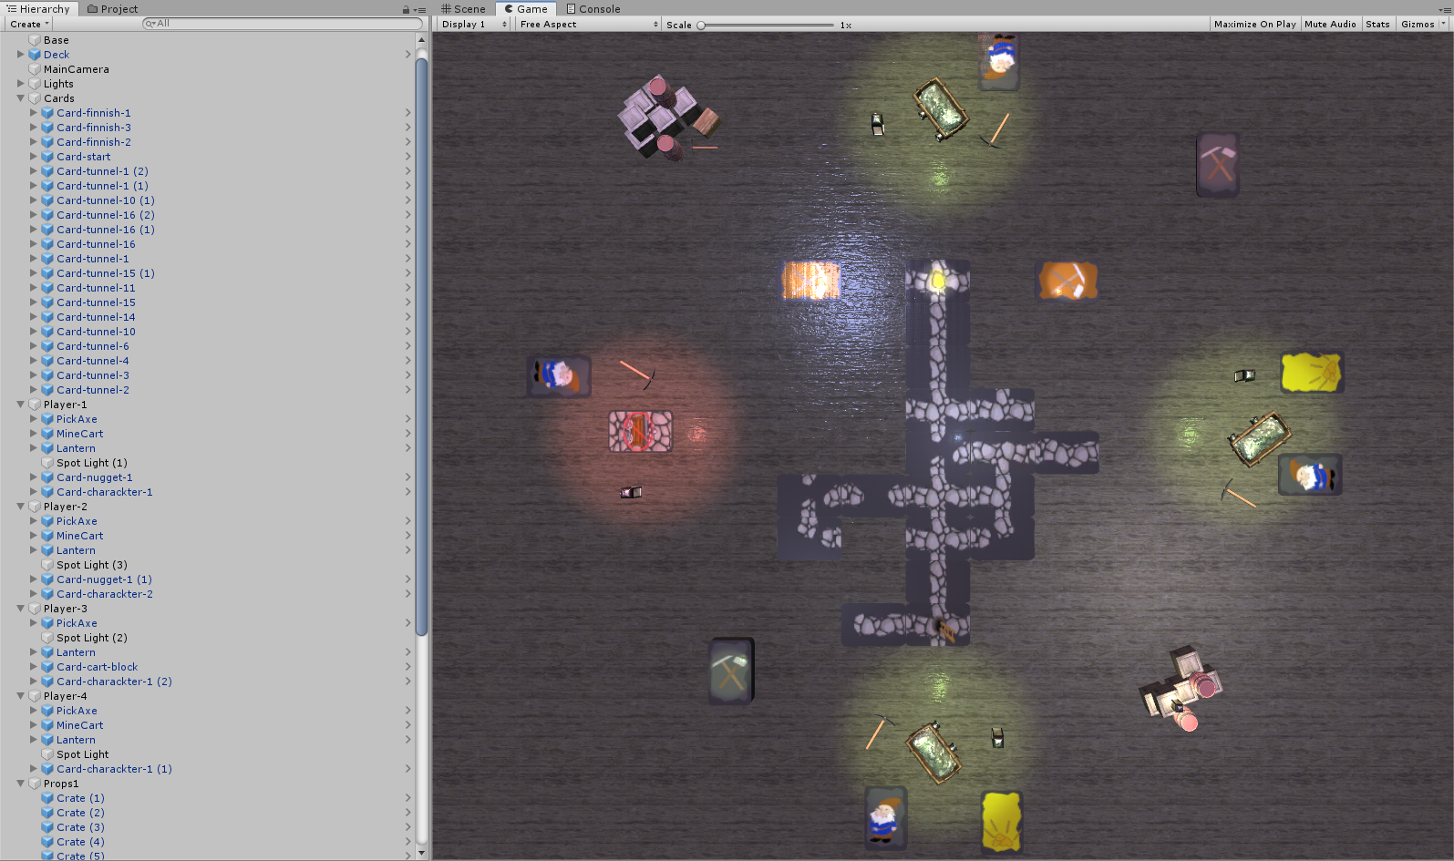

Figure 2 Enviornmental elements

### Task #3. Add lighting sources

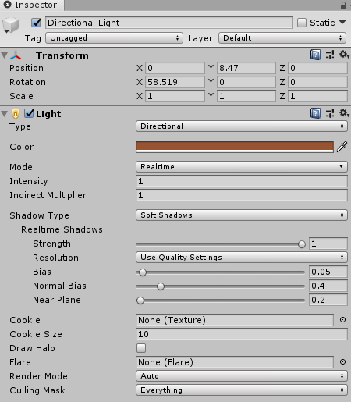Different types of light sources were added. Directional and point lights for overall table lightning, point lights for finish cards, player items etc. Some examples are:

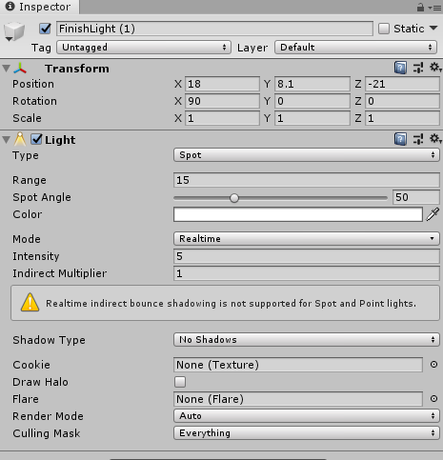

Figure 3 Light source example #1

Figure 4 Light source example #2

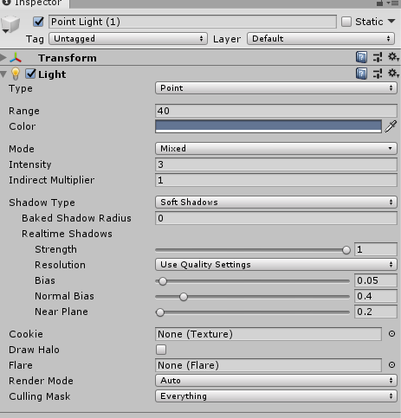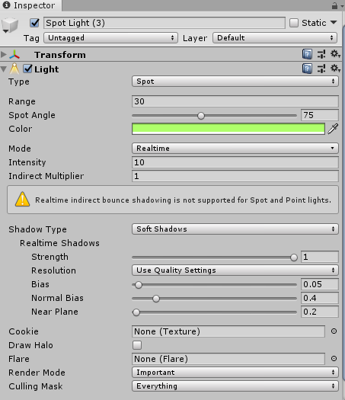

Figure 5 Light source example #3

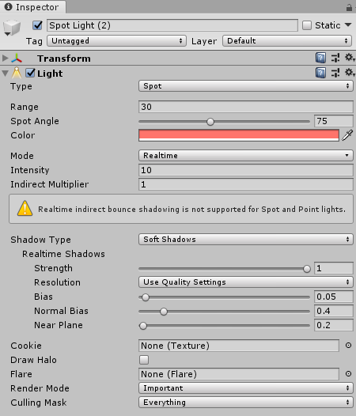Figure 6 Light source example #4

Figure 7 Light source example #5

### Task #4. Complement the map with sound

Since this is a board game and there will not be any movement on the map, background music will be played using playlist:

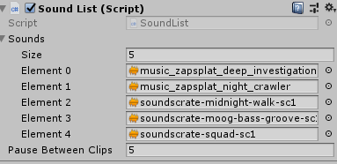

Some sounds are also added (water dripping, wind blowing). Also some sound effects (e.g. lantern breaking) will be added later in the game, when some logic will be implemented.

Table 1 SoundList fragment

|  |  |
| --- | --- |
| public class SoundList : MonoBehaviour  {  public AudioClip[] sounds;  public float pauseBetweenClips = 2f;  AudioSource audioSource;  int index = 0;  float timer = 0f;  bool timerRunning = false;  void Start()  {  audioSource = GetComponent<AudioSource>();  }    void Update()  {  if (!audioSource.isPlaying && !timerRunning)  {  audioSource.Stop();  timerRunning = true;  timer = 0f;  }  if (timerRunning)  {  timer += Time.deltaTime;  }  if (timer >= pauseBetweenClips)  {  audioSource.clip = sounds[index++];  audioSource.Play();  timerRunning = false;  timer = 0f;  if (index >= sounds.Length)  {  index = 0;  }  }  }  } | |
| **Start** | Finds AudioSource component |
| **Update** | Waits until AudioSource component is not playing and then plays the next audio track from the list |

### Task #5. Use at least 20 different materials

Different materials for all card textures were used, and some environment materials (wooden surface, metal, etc.):

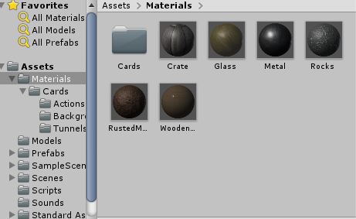

Figure 8 Material preview

# Literature list

Resources used from:

* <https://www.textures.com/download/pbr0139/133174>
* <https://www.textures.com/download/3dscans0079/128150>
* <https://www.freelancer.com/contest/Concept-Art-SKETCH-Gnome-390351-byentry-8768095>
* <https://www.freepik.com/free-vector/cartoon-stone-texture_976364.htm>
* <https://www.vectorstock.com/royalty-free-vector/mine-cart-with-coal-vector-1747485>
* <https://all-free-download.com/free-vector/download/treasure-map-clip-art_23028.html>
* <https://www.kisspng.com/png-cartoon-ladder-illustration-cartoon-wooden-ladder-497343/>
* <https://www.turbosquid.com/3d-models/pickaxe-obj-free/912027>
* <https://sketchfab.com/3d-models/mine-cart-2beeab5f44704421bc10cd310db96860>
* <https://www.textures.com/download/3dscans0110/130564>
* <https://www.textures.com/download/pbr0031/133067>
* <https://sketchfab.com/3d-models/lantern-final-aead6bb3bab344eaab541c5ac52c657c>
* <https://sketchfab.com/3d-models/40-rocks-a6c5ab5b438f473cb1cafdf4099e1657>
* <https://free3d.com/3d-model/crate-86737.html>
* <https://free3d.com/3d-model/barrel-7685.html>
* <https://free3d.com/3d-model/wooden-chest-44006.html>
* sounds from <https://www.productioncrate.com> and <https://www.zapsplat.com>